Assignment 5 Writeup

Carson Batchelor

1. Assess the validity of the experiment. Is there reason to think we've solved the problem of confounding? Did the intervention actually affect WFH rates? What does the excludability condition require here and how might it go wrong?

* Validity: The randomization appears to have worked because of balance means across key variable. There is no strong evidence of confounding because of all of the minor differences being within the range expected due to chance.

* Effect on WFH Rates: The intervention successfully increased WFH rates meaning that this intervention successfully increased WFH rates for the treatment group because of the large difference in means as shown below.

* Excludability Condition: While we aim to satisfy the excludability condition which means that the only way treatment affects the outcome is though allowing employees to work at home, there are potential concerns about team dynamics, manager perception, or volunteer effects that might indirectly influence the outcomes.
  + Team dynamic – employees who are assigned to work at home may interact with their teams differently in a negative way
  + Manager perception – Managers may expect different work from those assigned to the treatment group and those not which could affect performance
  + Volunteer status – The status of volunteers could differ systematically in ways that are not related to treatment.

1. What does the experiment show for the effect of HWFH on quit rate and performance.  Be sure to include confidence intervals.

* Quit Rate Effect – Appears that Hybrid work has a statistically significant and meaningful impact on reducing quit rates

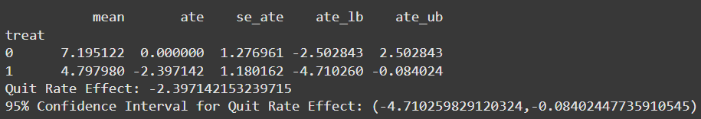

* Performance Effect – There is no clear evidence that hybrid works has a statistically significant or meaningful effect on performance

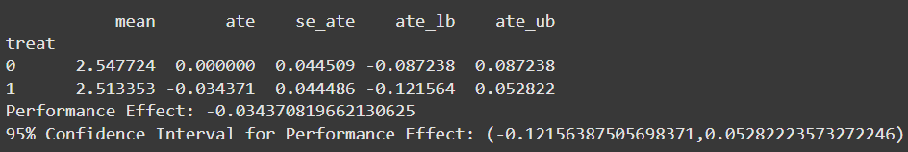

1. What does the excludability condition require here? How might it go wrong?

* The treatment and control group should only differ in their access to the hybrid work option and the differences calculated should be the reason for the effect. There should be no spillover effect, and the hybrid work should not change the outcomes through other means such as changing team dynamics.
* This could go wrong because the hybrid work option could lead to changes in the overall workplace culture which would affect the outcome and results. There could also be some interference in the experiment because of hybrid work affecting team dynamics and communication abilities.

1. Is there any reason to be concerned about differential attrition when looking at quit rates? What about performance?

* There could be a few reasons that cause concern about differential attrition when looking at quit rates. If the control and the treatment groups are systematically different such as employees selected for treatment being more adept to the change to hybrid work, it would cause some sort of selection bias. Also, it is a unique situation because it seems like we are actually trying to measure the attrition because the quit rate outcome metric is from employees leaving the organization/leaving the experiment.
* I believe that differential attrition could also cause some concern for performance for similar reasons. Managers may have certain biases with more highly performing employees regardless of what group they were selected and try to retain them which introduces some bias. There could also be systematic differences in those who quit early from the treatment group that was not solely caused from switching to hybrid work.

1. Summarize your findings: what does the experiment show about the value of HWFH? Would you recommend scaling up HWFH? Is there any additional information you'd like, or further experiments you would run? (You should make a recommendation regardless.)

* Employees offered the HWFH option had a significantly lower quit rate than those in the control group.
  + The estimated average treatment effect (ATE) on quit rates is -2.40 percentage points with a 95% confidence interval of (-4.71, -0.08).
  + This result is statistically significant, suggesting that HWFH effectively reduces attrition.
* The ATE on performance is -0.034 points, with a 95% confidence interval of (-0.122, 0.053).
  + This result is not statistically significant, meaning that there is no conclusive evidence that HWFH meaningfully impacts performance
* I recommend scaling up the HWFH policy
  + Lower quit rates can reduce costs associated with recruiting and help save lost performance due to employees quitting. Also, keeping employees leads to better overall stability in the company.
  + No significant negative impact on performance shows that there is no need to worry about productivity loss if people change to hybrid work.
* I think having more information about the employees could help with the analysis by supplying information about different employee groups and the difference in demographic information.
* I would also need to do a more long-term study to get a true understanding of the results.
* A follow up study in the form of talking to employees about the effect of hybrid work on team dynamics.

1. **Extra credit  (25%)**Using the Lee bounds trimming approach, construct bounds on the ITT (for performance). What do the bounds imply for practical significance?



* With narrow bounds like -0.0344 to -0.0344, the Lee bounds suggest minimal or no practical impact of HWFH on performance.